Duties | Rate /Hr AED | No Of Staff |  | No. Days | Date |  | No. of Hours / Day | Total
 |  | Male | Female |  | From | To
Stand Hostess | 125/-
Hospitality Staff | 80/-
 |  |  |  |  |  |  | Total
 |  |  |  |  |  |  | VAT 5%
 |  |  |  |  |  |  | Grand Total

VAT / Other Taxes: 5% VAT is applicable on the total of the above cost. Any additional taxes or charges imposed by the Government will be added to the above cost.

Supplemental Provisions:
-Staff rates include Transportation, Personal Accident, Public liability, and Employer’s Liability insurance.
-Vibes staff are required to wear their own formal black business suit / white shirt and black closed shoes. Any other uniform requirement to be provided by the client.
-Vibes shall invoice on an hourly basis, with a minimum of 6 hours per day, which shall be rounded up to the nearest hour.

Last Minute Request:
-Any last-minute request can be accommodated depending on the requirement. Payment for such request can be made by cash onsite two days prior to the starting date of the event.

Project Cancellation:
- After receiving the payment up to 7 days prior to the PCR test date/training/start of the event, 30% of the total staffing billing.
- Less than 7 days prior to the PCR test date/training/start of the event, 50% of the total staffing billing.
- On the PCR test date/training day/during event days, 100% of the total staffing billing.

Terms of Payment:
-Staff booking is upon receipt of 100% advance payment upon confirmation by wire transfer based on the bank details below.
-Online / debit / credit card payment option is not applicable.

Bank Details:
Account Name : Vibes Events
Account No : 101-13285599-02
IBAN : AE820260001011328559902
Bank Name : Emirates NBD
Branch : Al Muhairy Centre Branch Abu Dhabi UAE
Swift Code : EBILAEAD

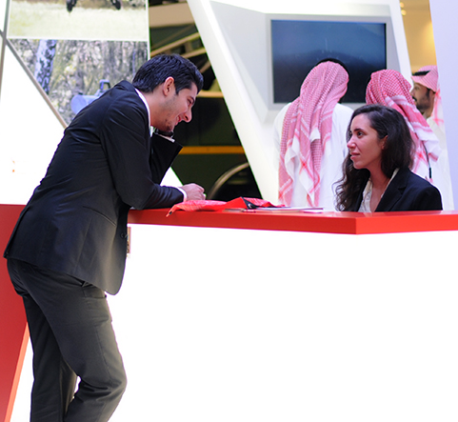
What are the hostess’s responsibilities?
Hostess
- Assists the client and attendees at the stand
- Creates warm and inviting atmosphere for visitors
- Meets and greets visitors in a friendly and professional manner
- Provides visitors with information they need and answer other question/clarification
- Supports with promotional activities, distributes brochures or giveaways, if applicable
- Handles incoming requests from visitors and ensures that issues
are resolved both promptly and thoroughly with close coordination with the exhibitor representative.

Are there any tasks that the hostess DOESN’T DO?
- Hostess DOES NOT prepare and serve coffee, tea, snacks or other refreshments.
For the above request, we recommend to book hospitality staff as an additional support to hostess.
- Hostess DOES NOT clean or mop floors, etc.
For the above responsibilities, you may contact the official housekeeping provider of the event.

Should we provide uniform for the staff?
- Vibes standard dress code is black business suit and white shirt. Any other required uniform is to be provided by the client.

How are break times managed? Should we provide food to the staff?
- For 8 hours work per day, Vibes staff should be allowed at least 30 minutes lunch break
- For 9 hours work (and above) per day, Vibes staff should be allowed for 45 minutes lunch break
- Vibes staff is responsible for their own lunch

When can we conduct the briefing?
- Staff can come 30 minutes earlier on the first day of the show for the briefing, FREE OF COST. Any other request will be billed accordingly.

